ASSIGNMENT 1

1. Display the first and last name of each actor in a single column in upper case letters in alphabetic order. Name the column Actor Name.

SELECT UPPER(CONCAT(first_name,' ',last_name)) AS `Actor Name` FROM actor ORDER BY `Actor Name`;

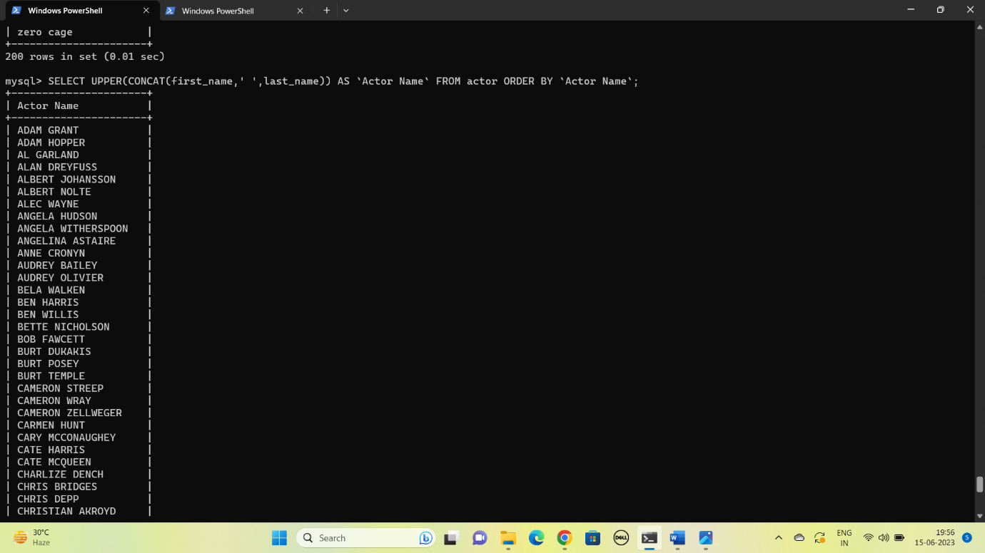

1. Find all actors whose last name contain the letters GEN:

SELECT CONCAT(first_name,' ',last_name) AS `Actor Name` FROM actor WHERE last_name LIKE '%GEN%' ORDER BY `Actor Name`;

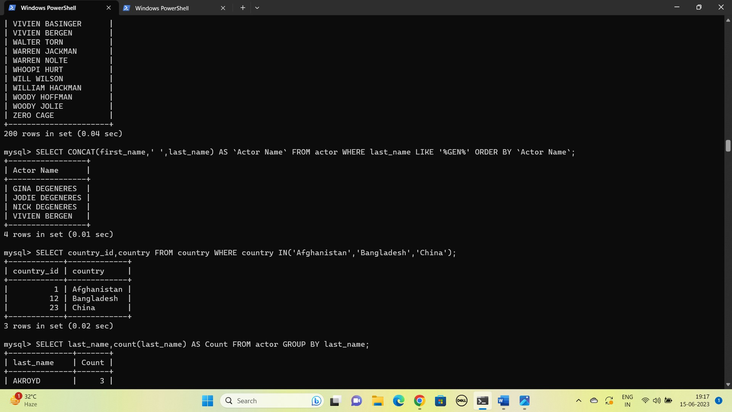

1. Using IN, display the country_id and country columns of the following countries: Afghanistan, Bangladesh, and China:

SELECT country_id,country FROM country WHERE country IN('Afghanistan','Bangladesh','China');



1. List the last names of actors, as well as how many actors have that last name.

SELECT last_name,count(last_name) AS Count FROM actor GROUP BY last_name;

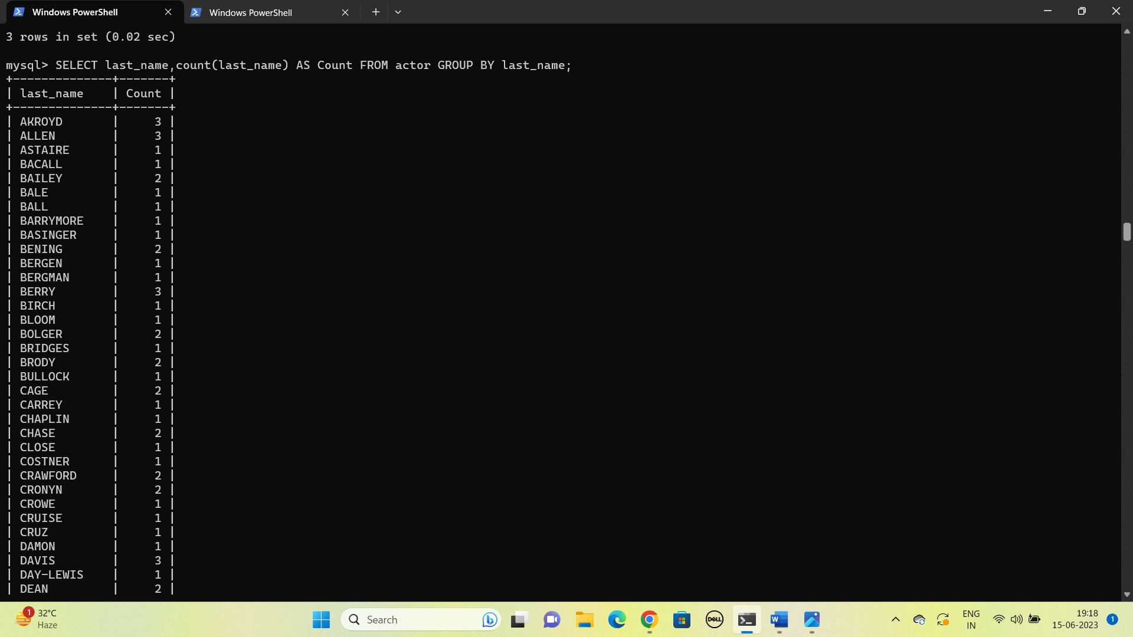

1. List last names of actors and the number of actors who have that last name, but only for names that are shared by at least two actors

SELECT last_name,count(last_name) AS Count FROM actor GROUP BY last_name HAVING Count>=2;

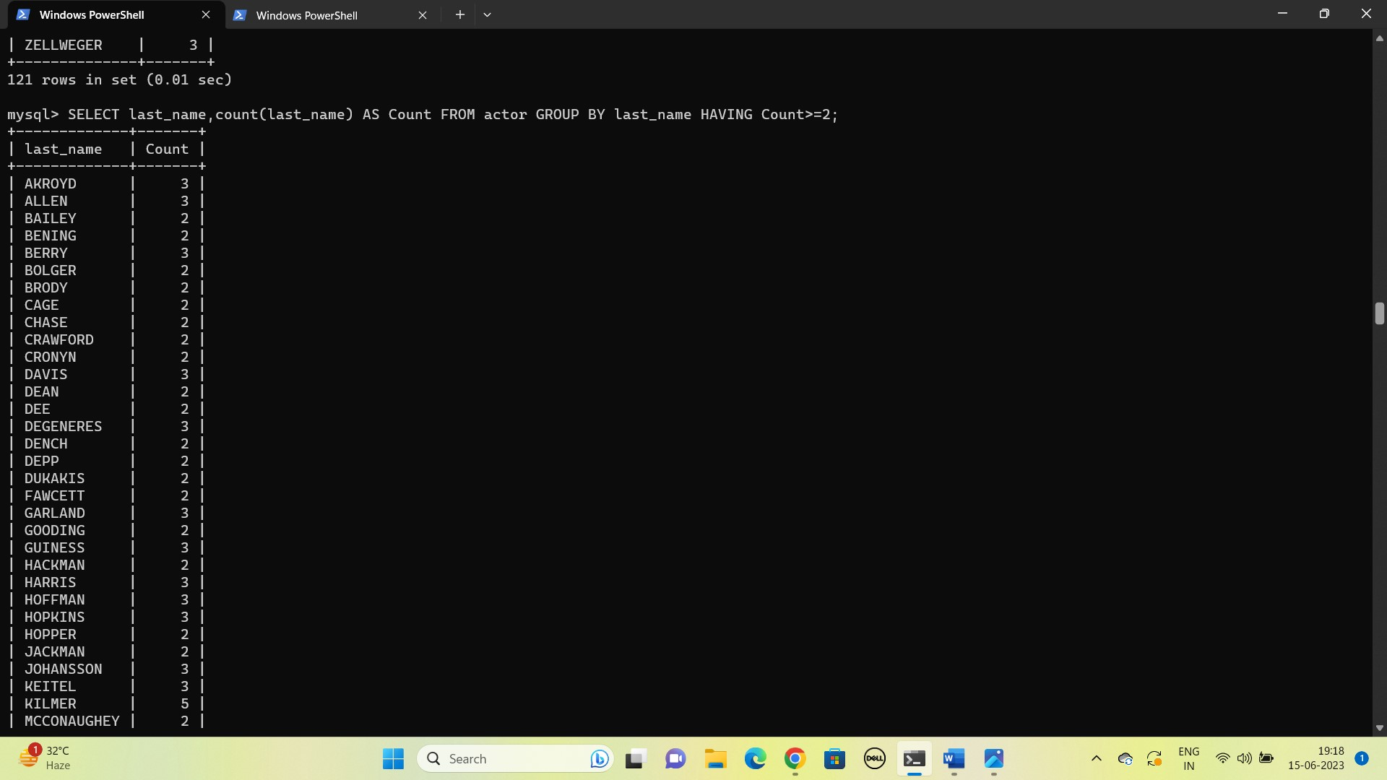

1. The actor HARPO WILLIAMS was accidentally entered in the actor table as GROUCHO WILLIAMS. Write a query to fix the record.

UPDATE actor SET first_name='HARPO' WHERE first_name='GROUCHO' AND last_name='WILLIAMS';

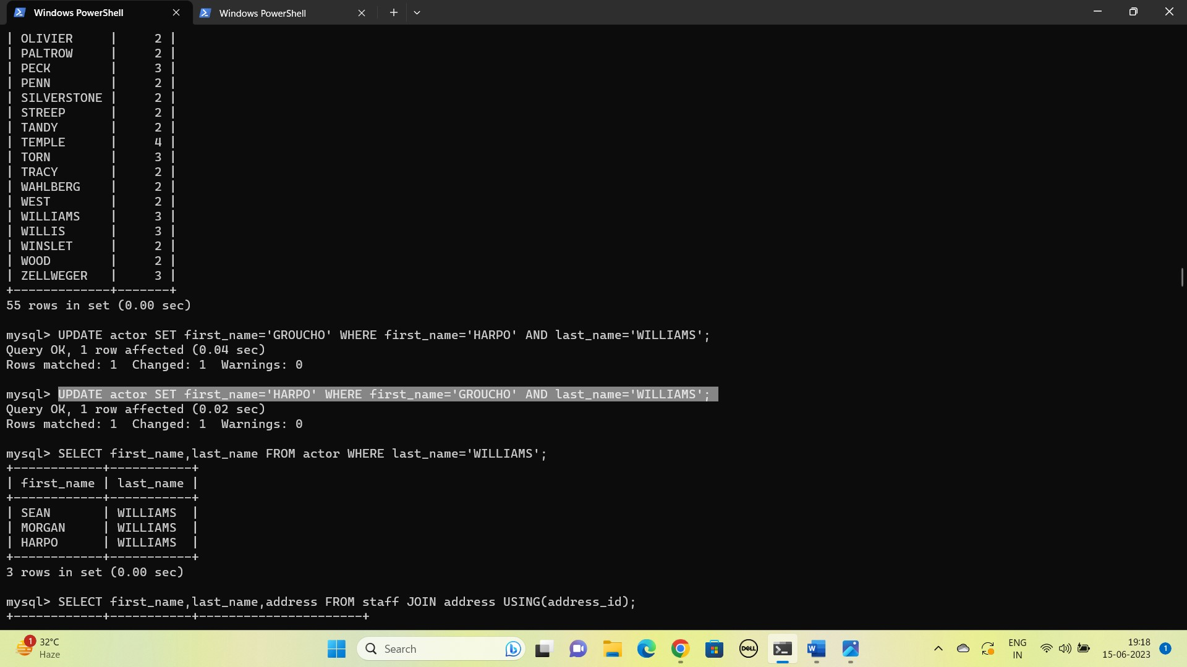

1. Use JOIN to display the first and last names, as well as the address, of each staff member. Use the tables staff and address:

SELECT first_name,last_name,address FROM staff JOIN address USING(address_id);

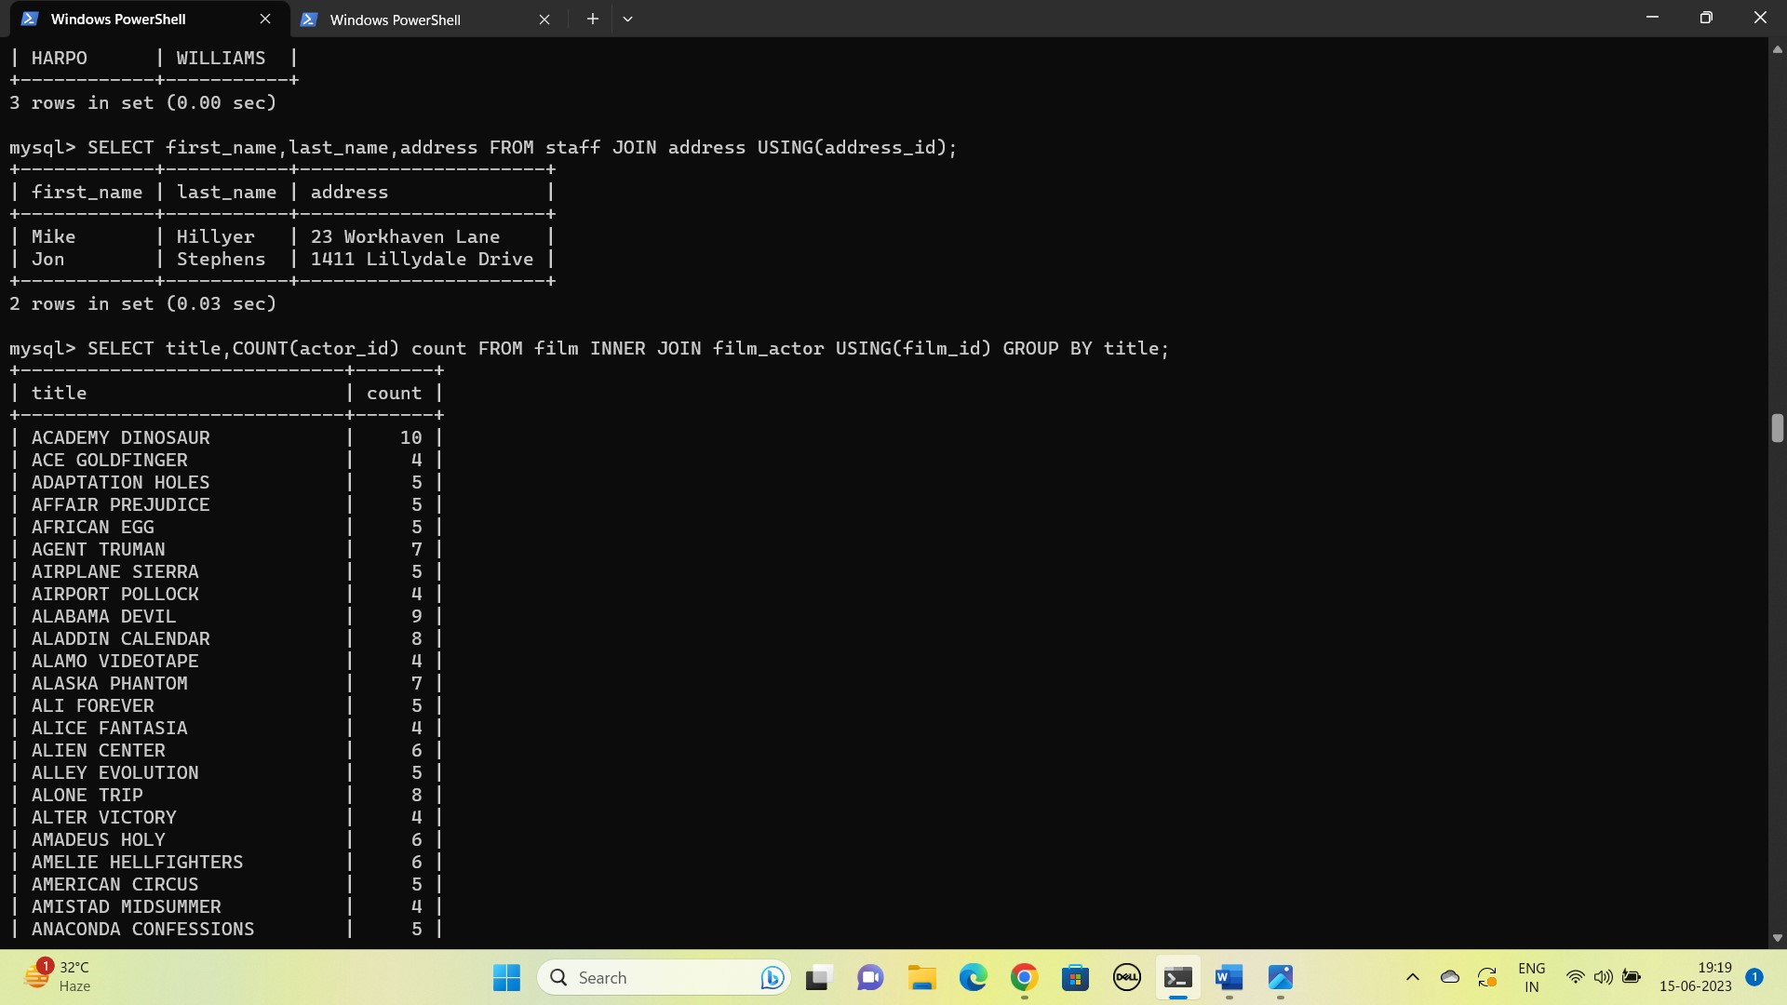

1. List each film and the number of actors who are listed for that film. Use tables film_actor and film. Use inner join.

SELECT title,COUNT(actor_id) count FROM film INNER JOIN film_actor USING(film_id) GROUP BY title;



1. How many copies of the film Hunchback Impossible exist in the inventory system?

SELECT title,COUNT(i.film_id) Copy FROM film JOIN inventory i USING(film_id) WHERE title='Hunchback Impossible';

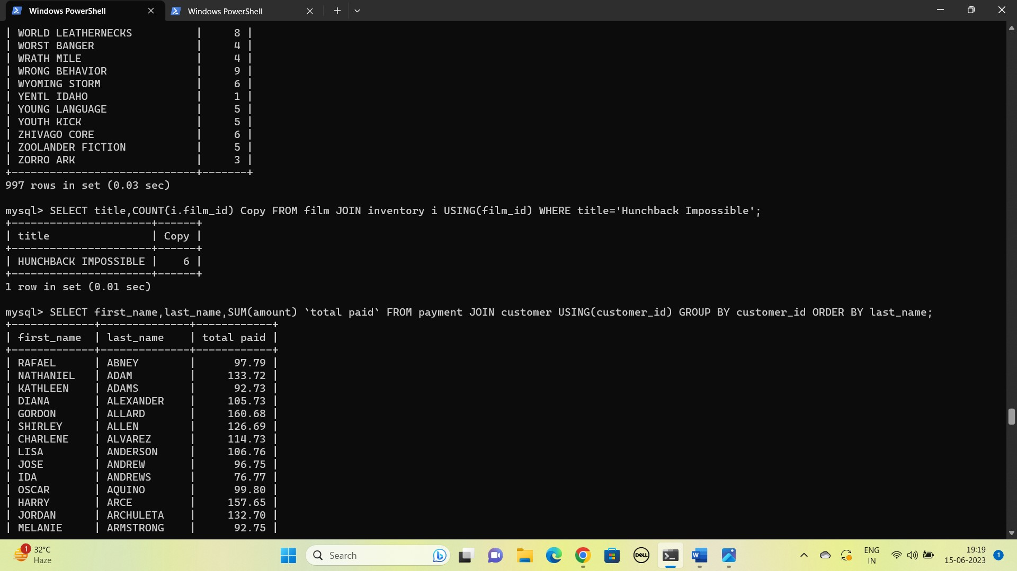

1. Using the tables payment and customer and the JOIN command, list the total paid by each customer. List the customers alphabetically by last name

SELECT first_name,last_name,SUM(amount) `total paid` FROM payment JOIN customer USING(customer_id) GROUP BY customer_id ORDER BY last_name;

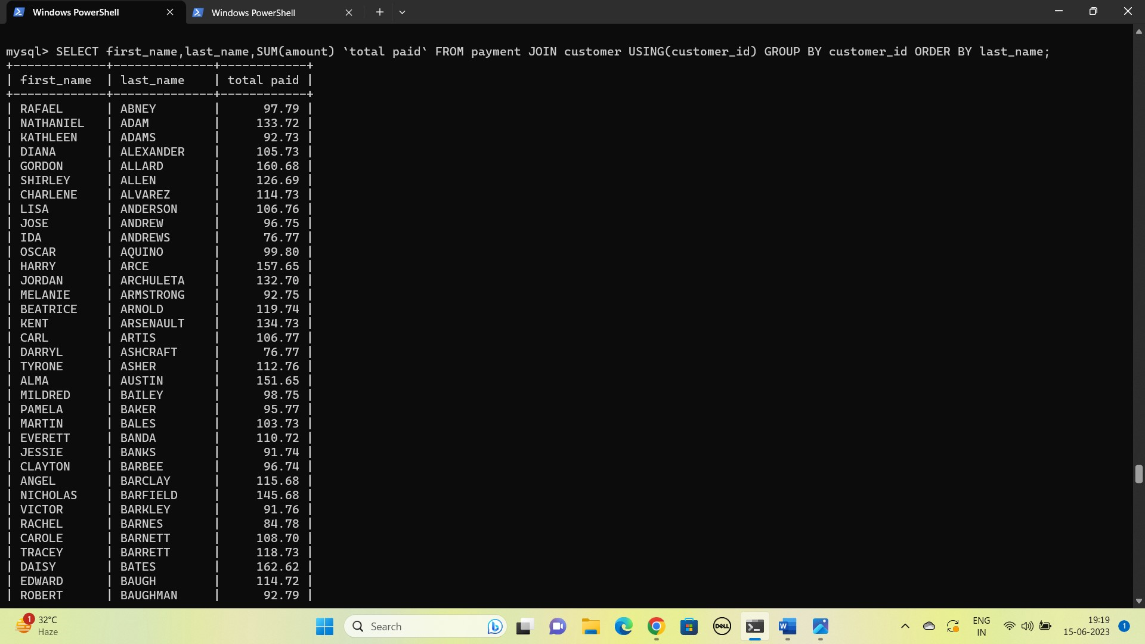

1. The music of Queen and Kris Kristofferson have seen an unlikely resurgence. As an unintended consequence, films starting with the letters K and Q have also soared in popularity. Use subqueries to display the titles of movies starting with the letters K and Q whose language is English.

SELECT title FROM film WHERE title LIKE 'K%' OR title LIKE 'Q%' AND language_id IN(SELECT language_id FROM language WHERE name='English');

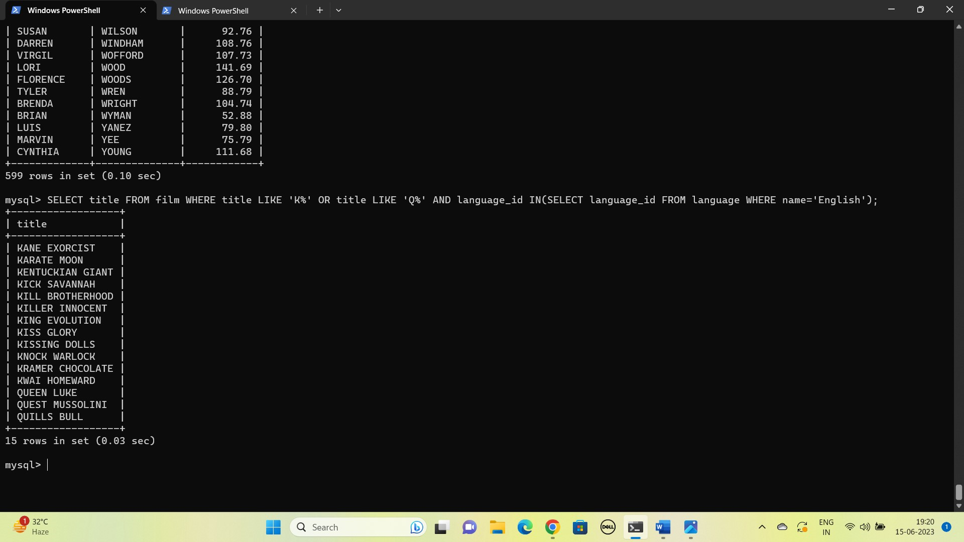

1. Use subqueries to display all actors who appear in the film Alone Trip.

SELECT first_name,last_name FROM actor WHERE actor_id IN(SELECT actor_id FROM film_actor WHERE film_id IN(SELECT film_id FROM film WHERE title='Alone Trip'));



1. You want to run an email marketing campaign in Canada, for which you will need the names and email addresses of all Canadian customers. Use joins to retrieve this information.

SELECT name,email FROM customer_list JOIN customer ON customer_id=ID WHERE country='Canada';

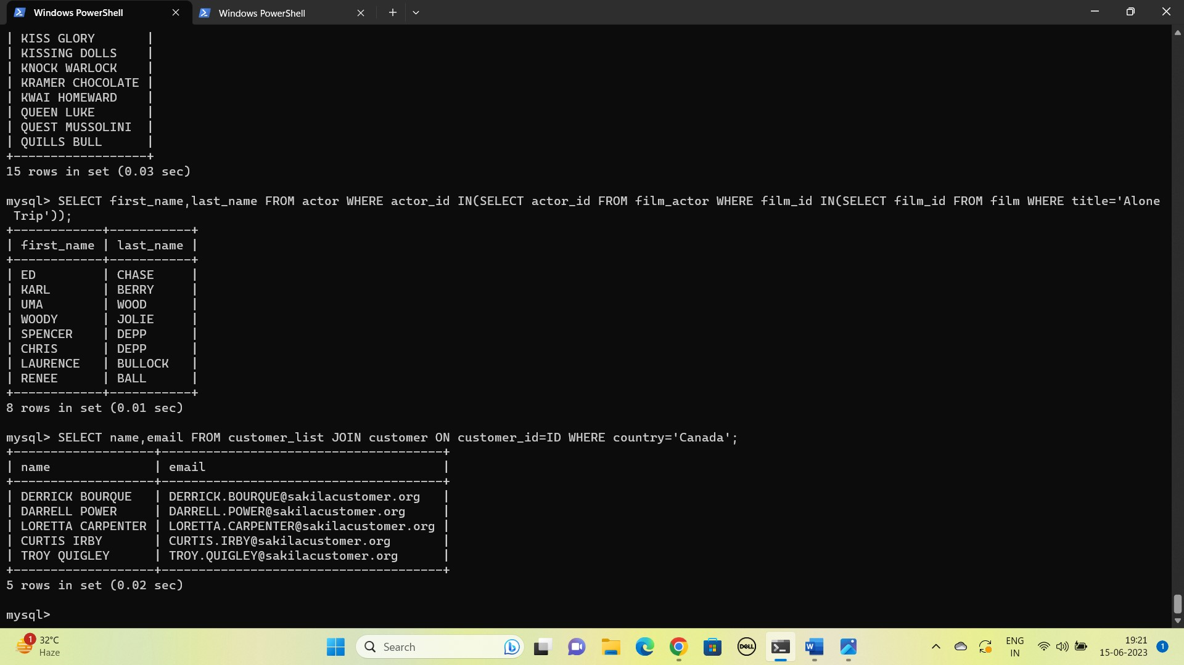

1. Sales have been lagging among young families, and you wish to target all family movies for a promotion. Identify all movies categorized as family films.

SELECT title,name FROM film f JOIN film_category fc ON f.film_id=fc.film_id JOIN category c ON fc.category_id=c.category_id WHERE c.category_id IN(SELECT category_id FROM category WHERE name='Family');

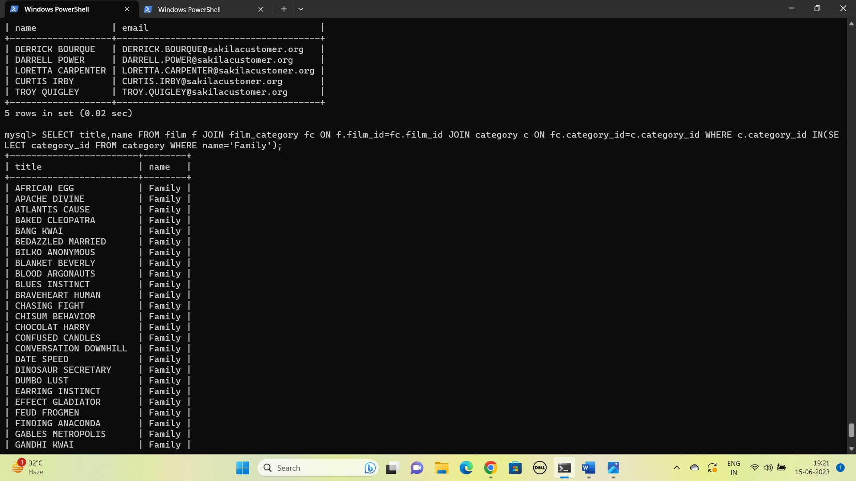

1. Create a Stored procedure to get the count of films in the input category (IN category_name, OUT count)

DELIMITER !

CREATE PROCEDURE film_count (

IN category_name VARCHAR(30),

OUT count INT )

BEGIN

SELECT COUNT(category_id) INTO count FROM category JOIN film_category USING(category_id) WHERE name=category_name;

END !

DELIMITER ;

CALL film_count('Family',@count);

SELECT @count;

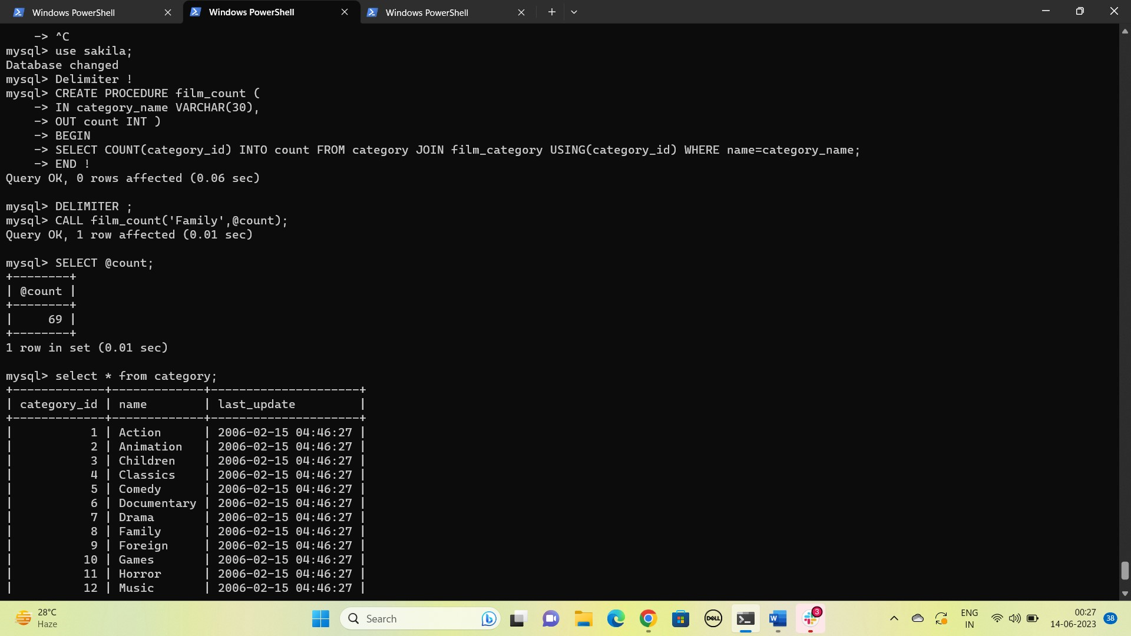

1. Display the most frequently rented movies in descending order.

SELECT title,count(r.inventory_id) rented FROM film f JOIN inventory i ON f.film_id=i.film_id JOIN rental r ON i.inventory_id=r.inventory_id GROUP BY title ORDER BY rented DESC;

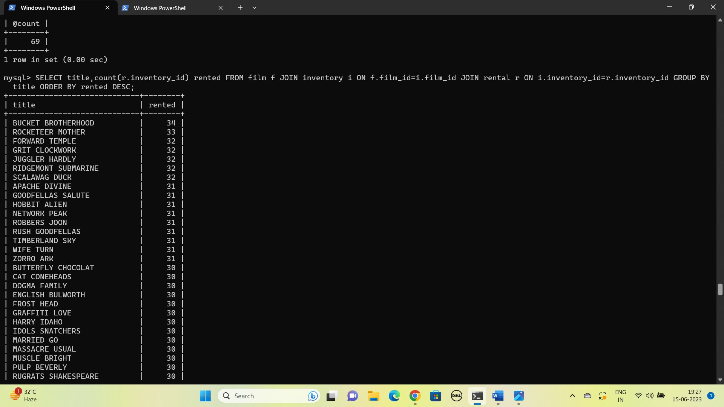

1. Write a query to display for each store its store ID, city, and country.

SELECT store_id, city, country FROM store s JOIN address a ON s.address_id=a.address_id JOIN city c ON a.city_id=c.city_id JOIN country co ON c.country_id=co.country_id;

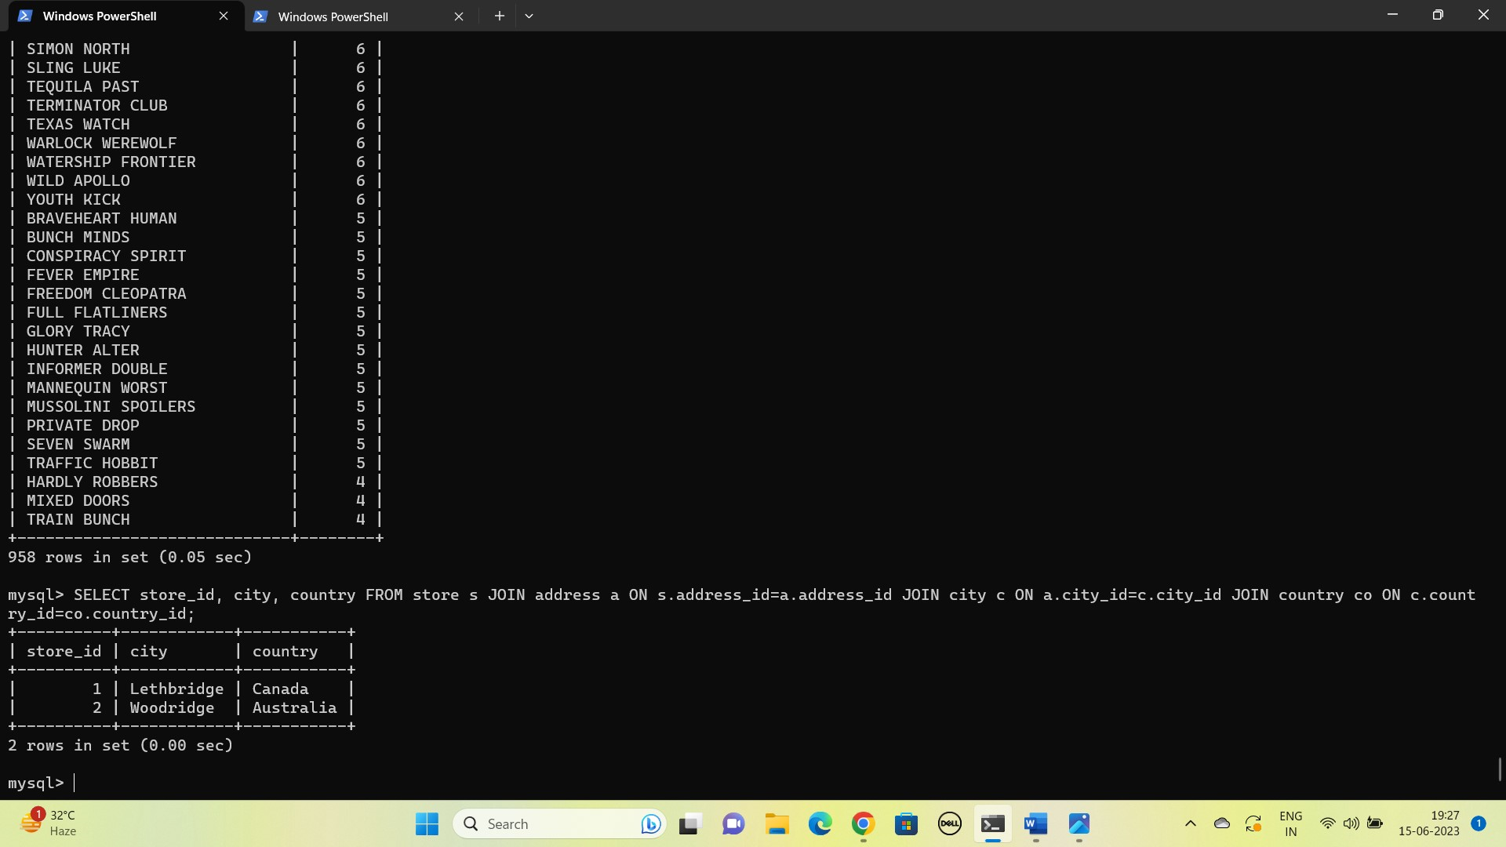

1. List the genres and its gross revenue.

SELECT name genre,sum(amount) `gross revenue` FROM category JOIN film_category USING(category_id) JOIN inventory USING(film_id) JOIN rental USING(inventory_id) JOIN payment USING(rental_id) GROUP BY name;

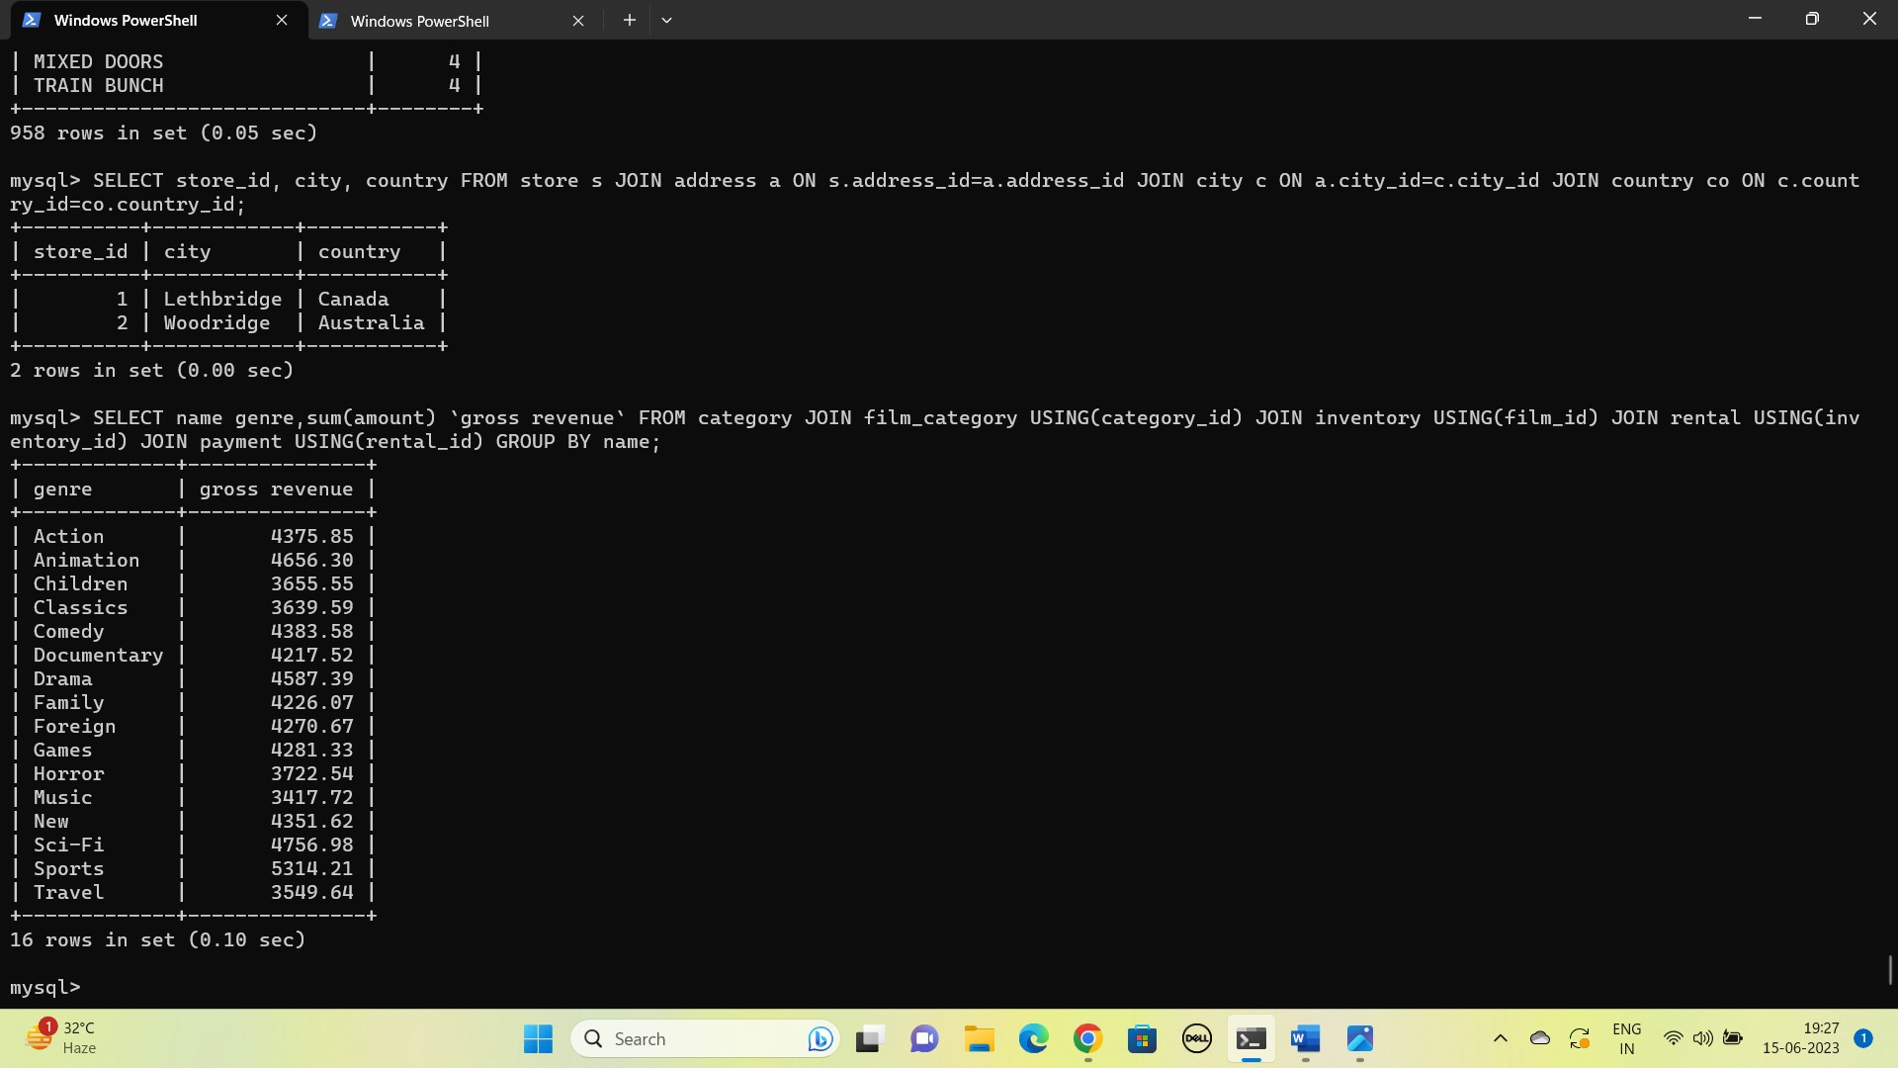

1. Create a View for the above query(18)

CREATE VIEW gross_revenue_by_genre AS SELECT name genre,sum(amount) `gross revenue` FROM category JOIN film_category USING(category_id) JOIN inventory USING(film_id) JOIN rental USING(inventory_id) JOIN payment USING(rental_id) GROUP BY name;

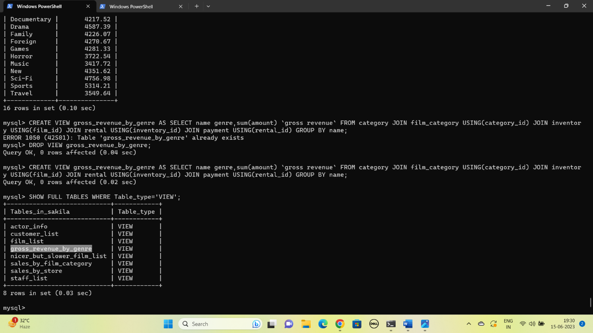

1. Select top 5  genres in gross revenue view.

SELECT * FROM gross_revenue_by_genre ORDER BY `gross revenue` DESC LIMIT 5;

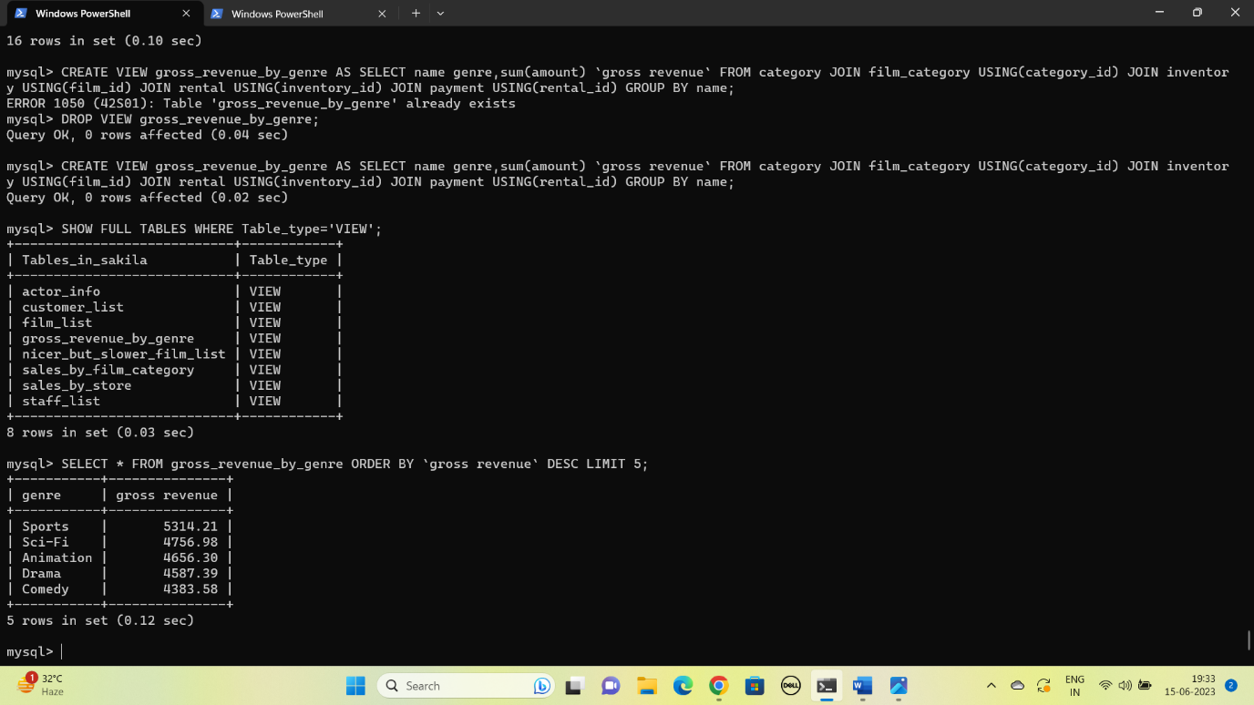

ASSIGNMENT 2

1. Select employees first name, last name, job_id and salary whose first name starts with alphabet S

SELECT first_name,last_name,job_id,salary FROM employees WHERE first_name LIKE 'S%';

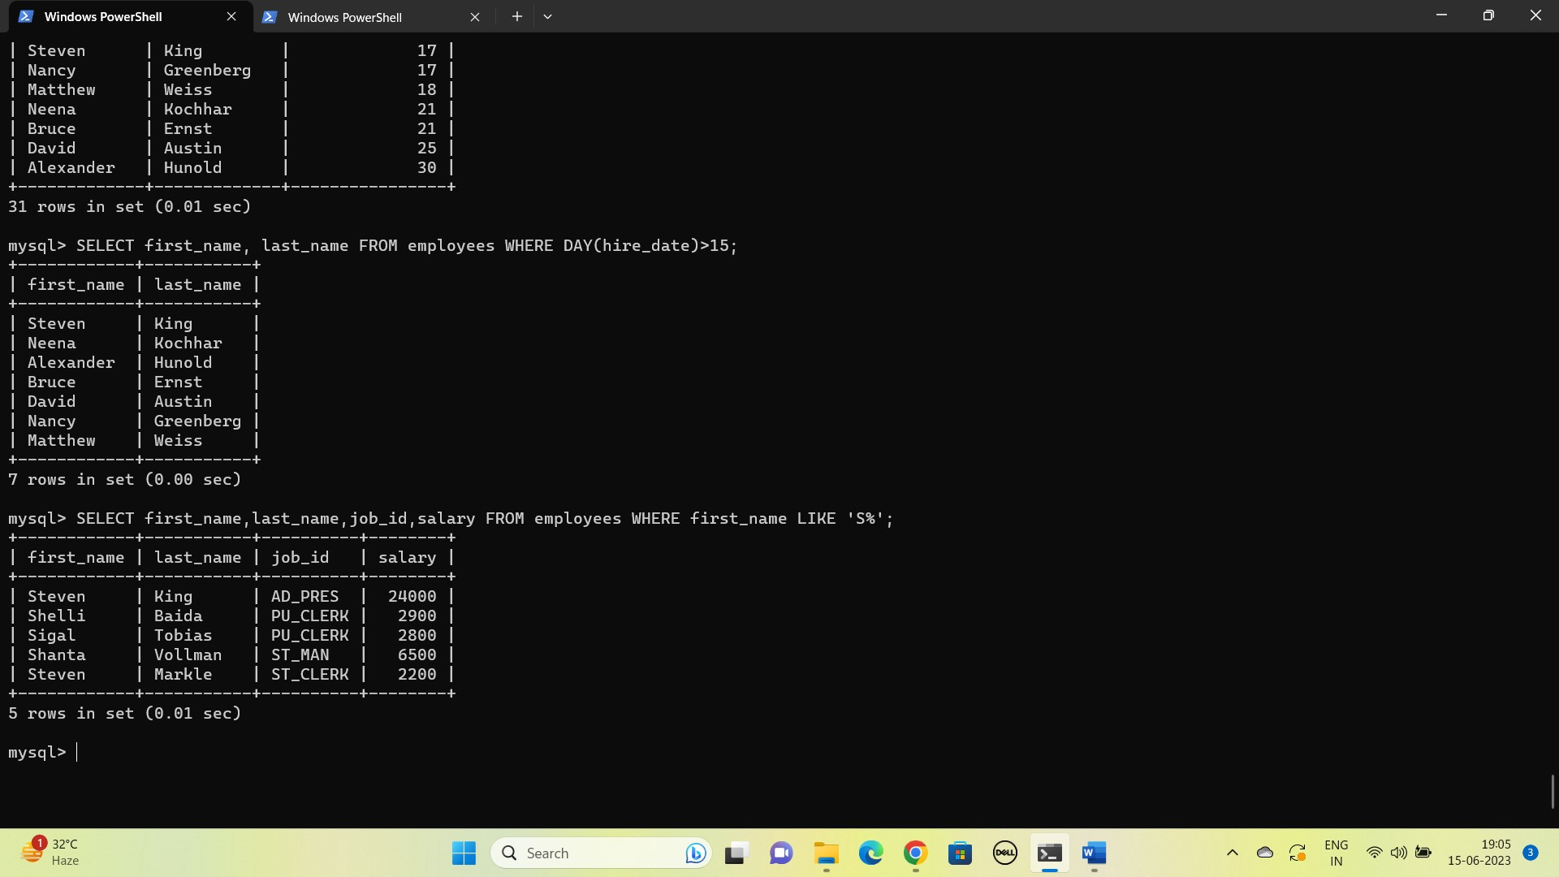

2. Write a query to select employee with the highest salary  (using inner query)

SELECT first_name,last_name,salary FROM employees WHERE salary IN(SELECT MAX(salary) FROM employees);

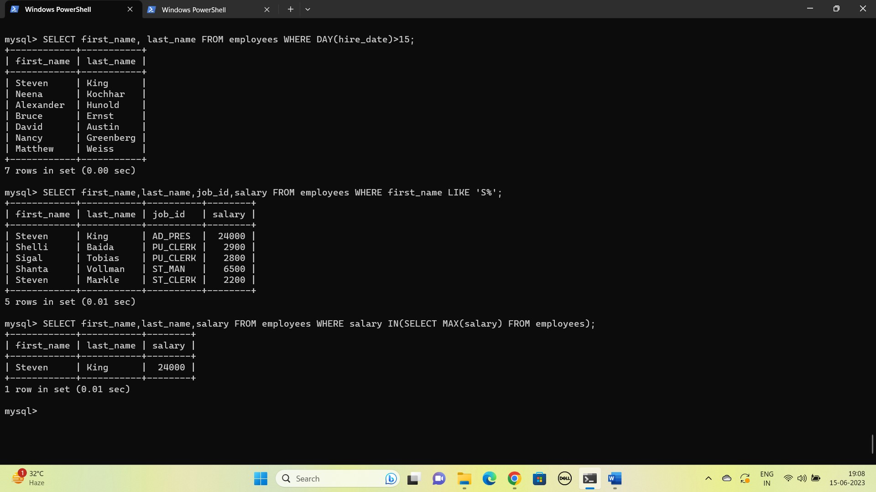

3. Select employee with the second highest salary

SELECT first_name,last_name,salary FROM employees WHERE salary IN(SELECT MAX(salary) FROM employees WHERE salary<(SELECT MAX(salary) FROM employees));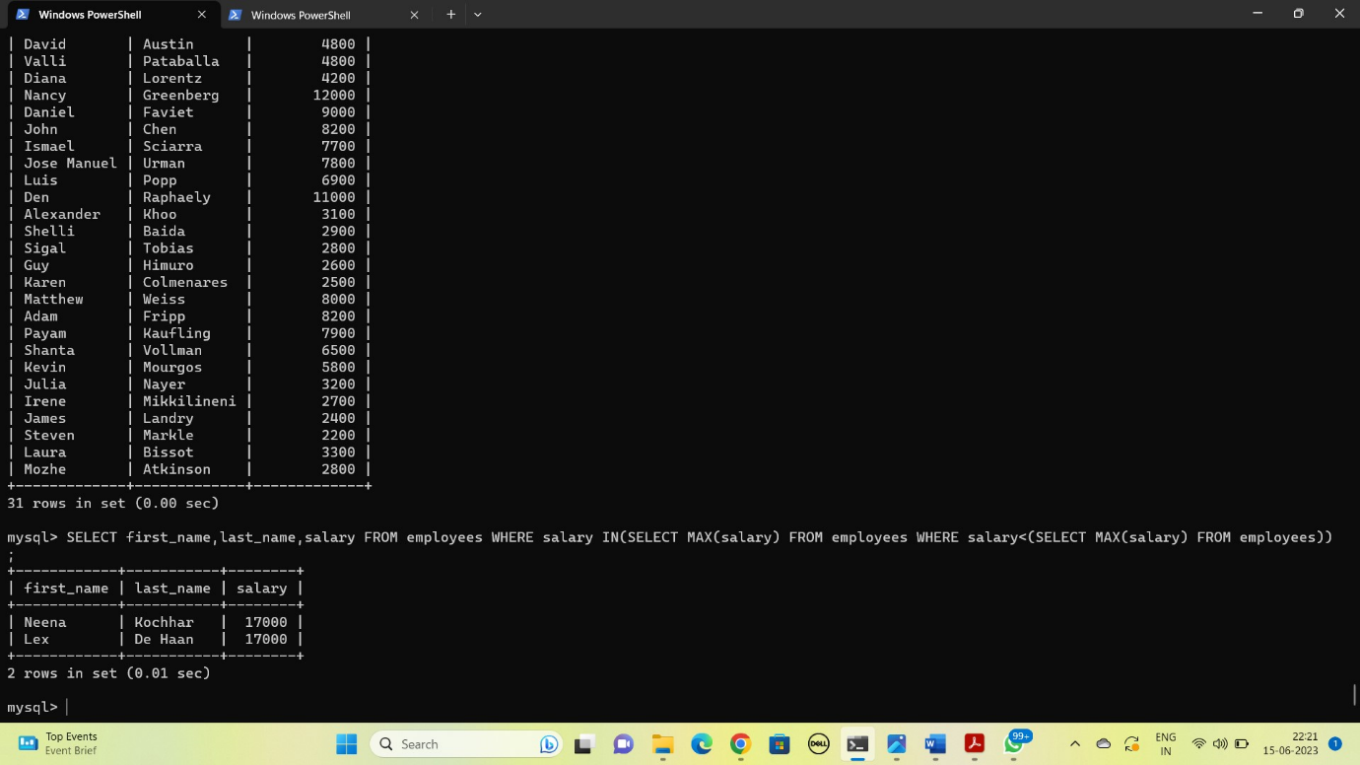

4. Write a query to select employees and their corresponding managers and their salaries (SELF Join)

SELECT CONCAT(a.first_name,' ',a.last_name) employee, CONCAT(b.first_name,' ',b.last_name) manager, a.salary FROM employees a LEFT JOIN employees b ON b.Employee_id=a.manager_id;

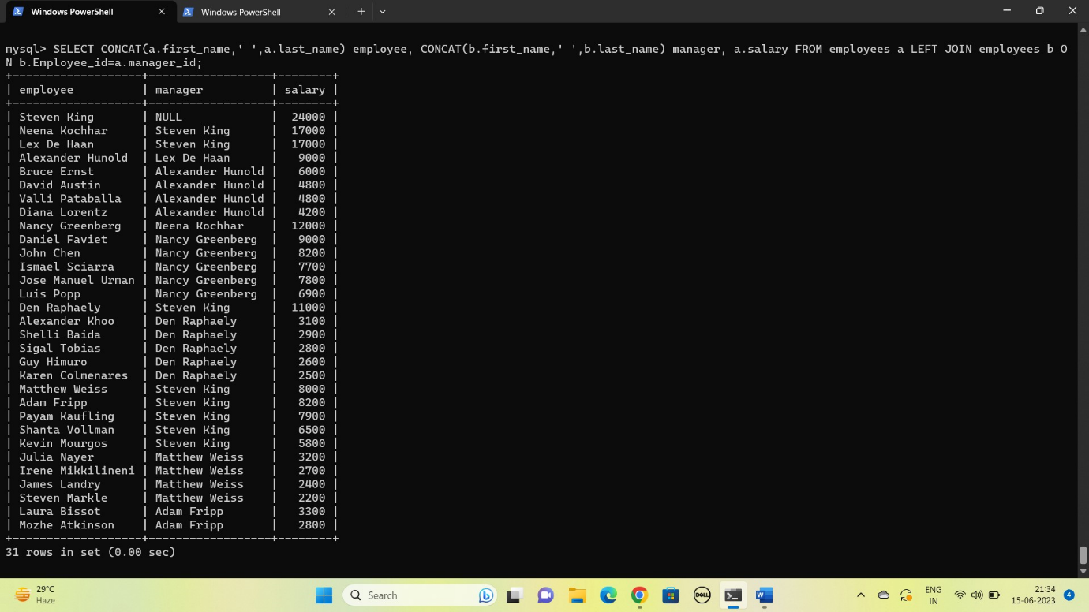

5. Create a view for the above query

CREATE VIEW manager_salary_of_employee AS SELECT CONCAT(a.first_name,' ',a.last_name) employee, CONCAT(b.first_name,' ',b.last_name) manager, a.salary FROM employees a LEFT JOIN employees b ON b.Employee_id=a.manager_id;

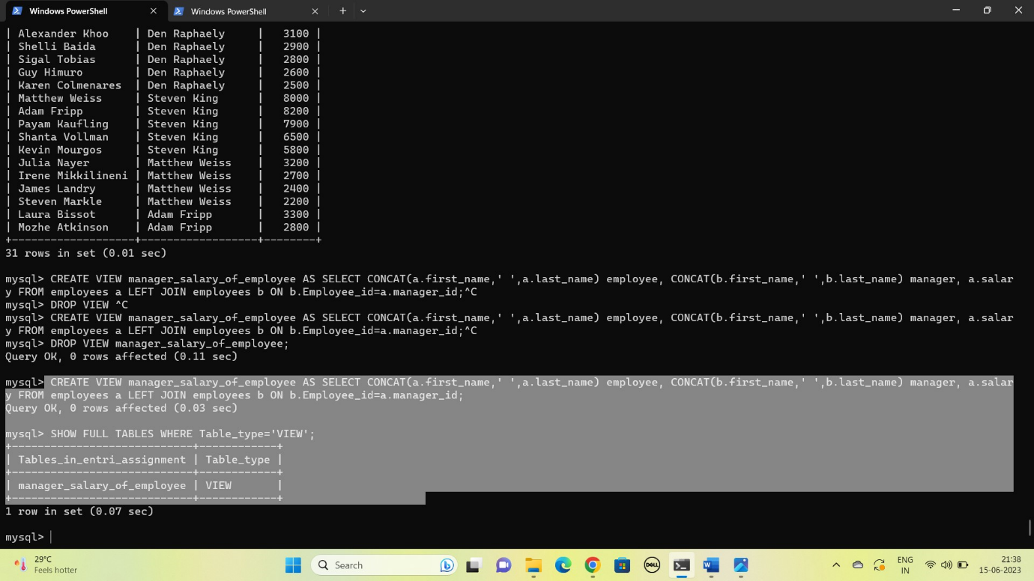

6. Write a query to show count of employees under each manager in descending order (from view)

SELECT manager, COUNT(employee) `Count of Employees` FROM manager_salary_of_employee GROUP BY manager;

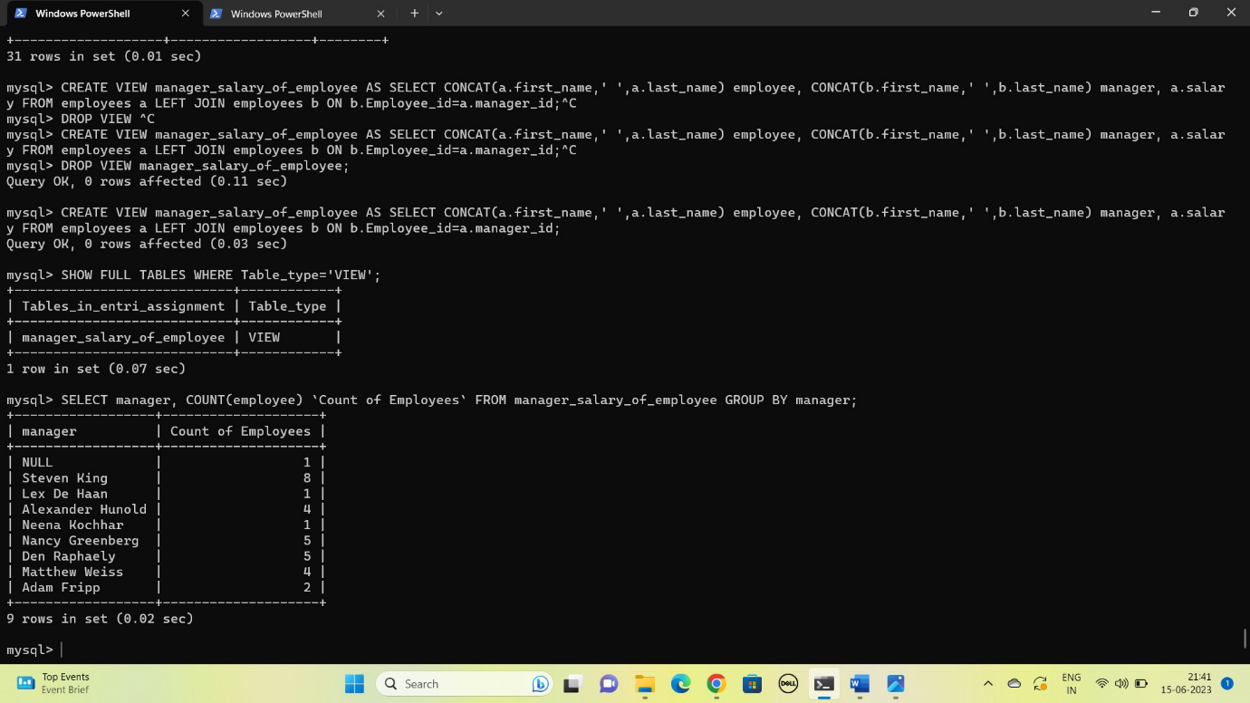

7. Find the count of employees in each department

SELECT Department_name AS Department, COUNT(Employee_id) AS `count of employees` FROM departments JOIN employees USING(department_id) GROUP BY Department;

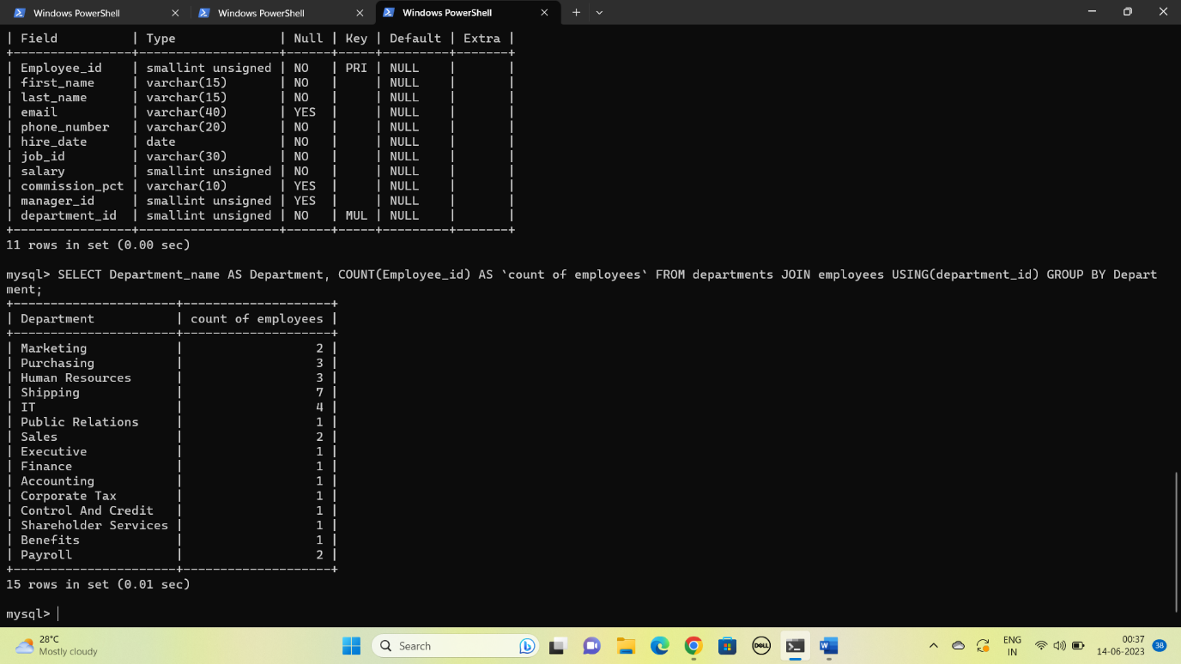

8. Get the count of employees hired year wise

SELECT COUNT(Employee_id) `count of employees`, YEAR(hire_date) year FROM employees GROUP BY year;

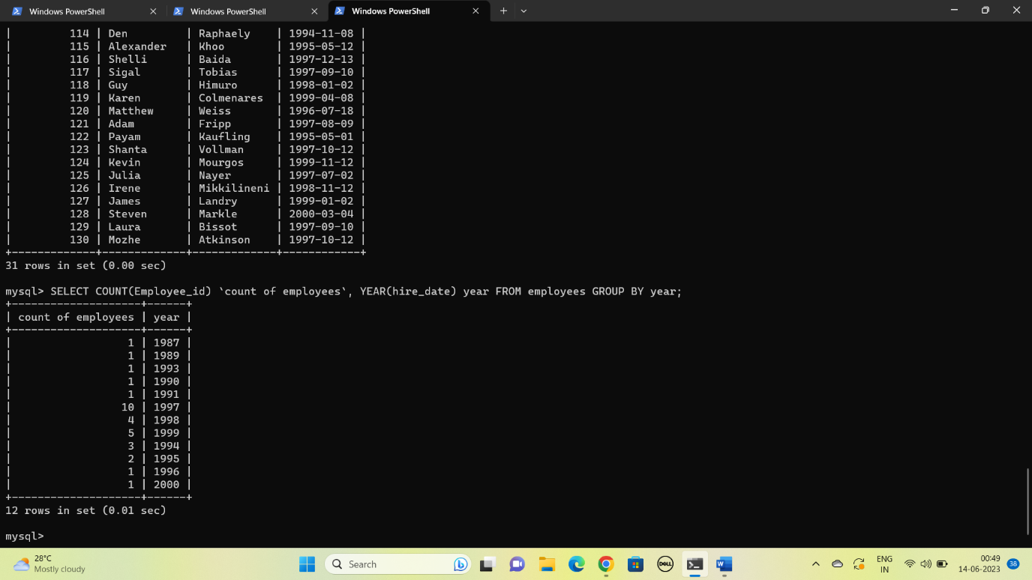

9 . create a stored procedure to get the “ Get the count of employees hired in the input year”(IN year , OUT count)

DELIMITER !

CREATE PROCEDURE employees_count_by_year (

IN year INT,

OUT count INT)

BEGIN

SELECT COUNT(employee_id) INTO count FROM employees WHERE YEAR(hire_date)=year;

END !

DELIMITER ;

CALL employees_count_by_year('1997',@count);

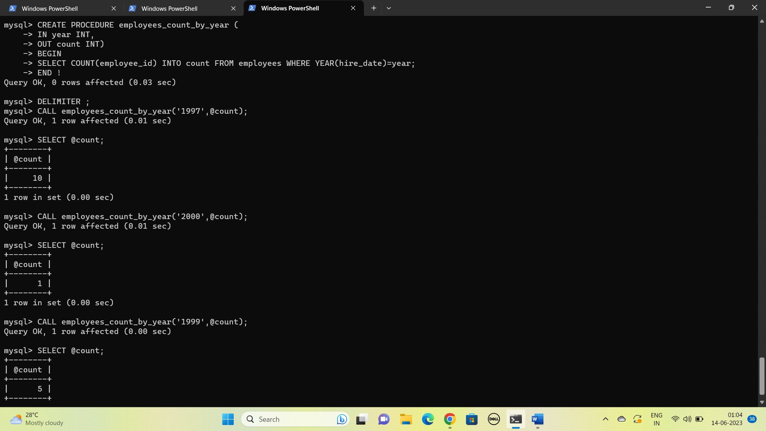

10.Select the employees whose first_name contains “an”

SELECT first_name,last_name FROM employees WHERE first_name LIKE '%an%';

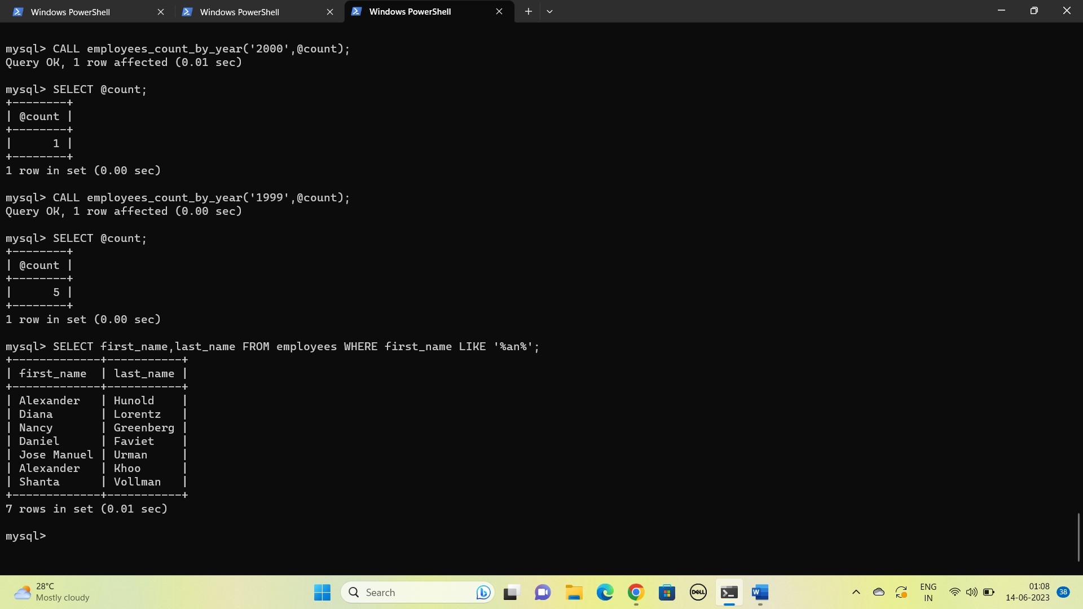

11.  Select employee first name and the corresponding phone number in the format (_ _ _)-(_ _ _)-(_ _ _ _)

SELECT GROUP_CONCAT(first_name,'-',phone_number SEPARATOR '-') FROM employees;

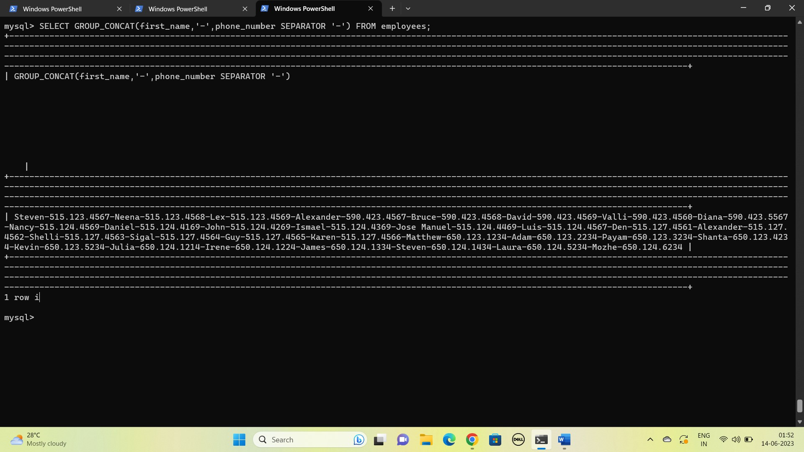

12. Find the employees who joined in August, 1994.

SELECT first_name, last_name FROM employees WHERE hire_date LIKE '1994-08-%';

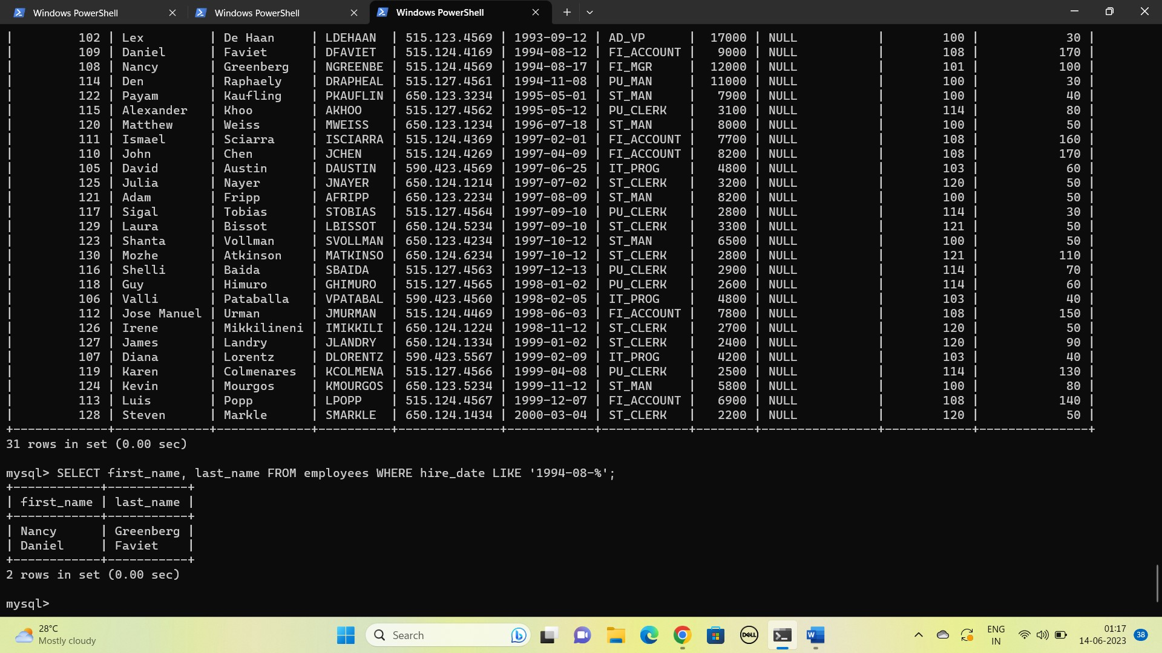

13. Find the maximum salary from each department.

SELECT Department_name Department ,MAX(salary) `Maximum Salary` FROM departments d JOIN employees e ON d.Department_id=e.department_id GROUP BY Department;

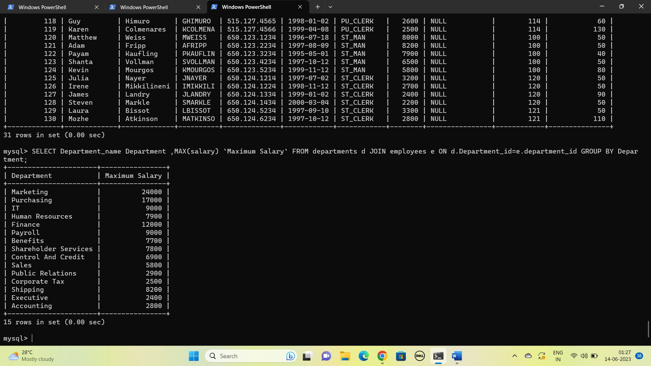

14.Write a SQL query to display the 5 least earning employees

SELECT first_name, last_name FROM employees ORDER BY salary LIMIT 5;

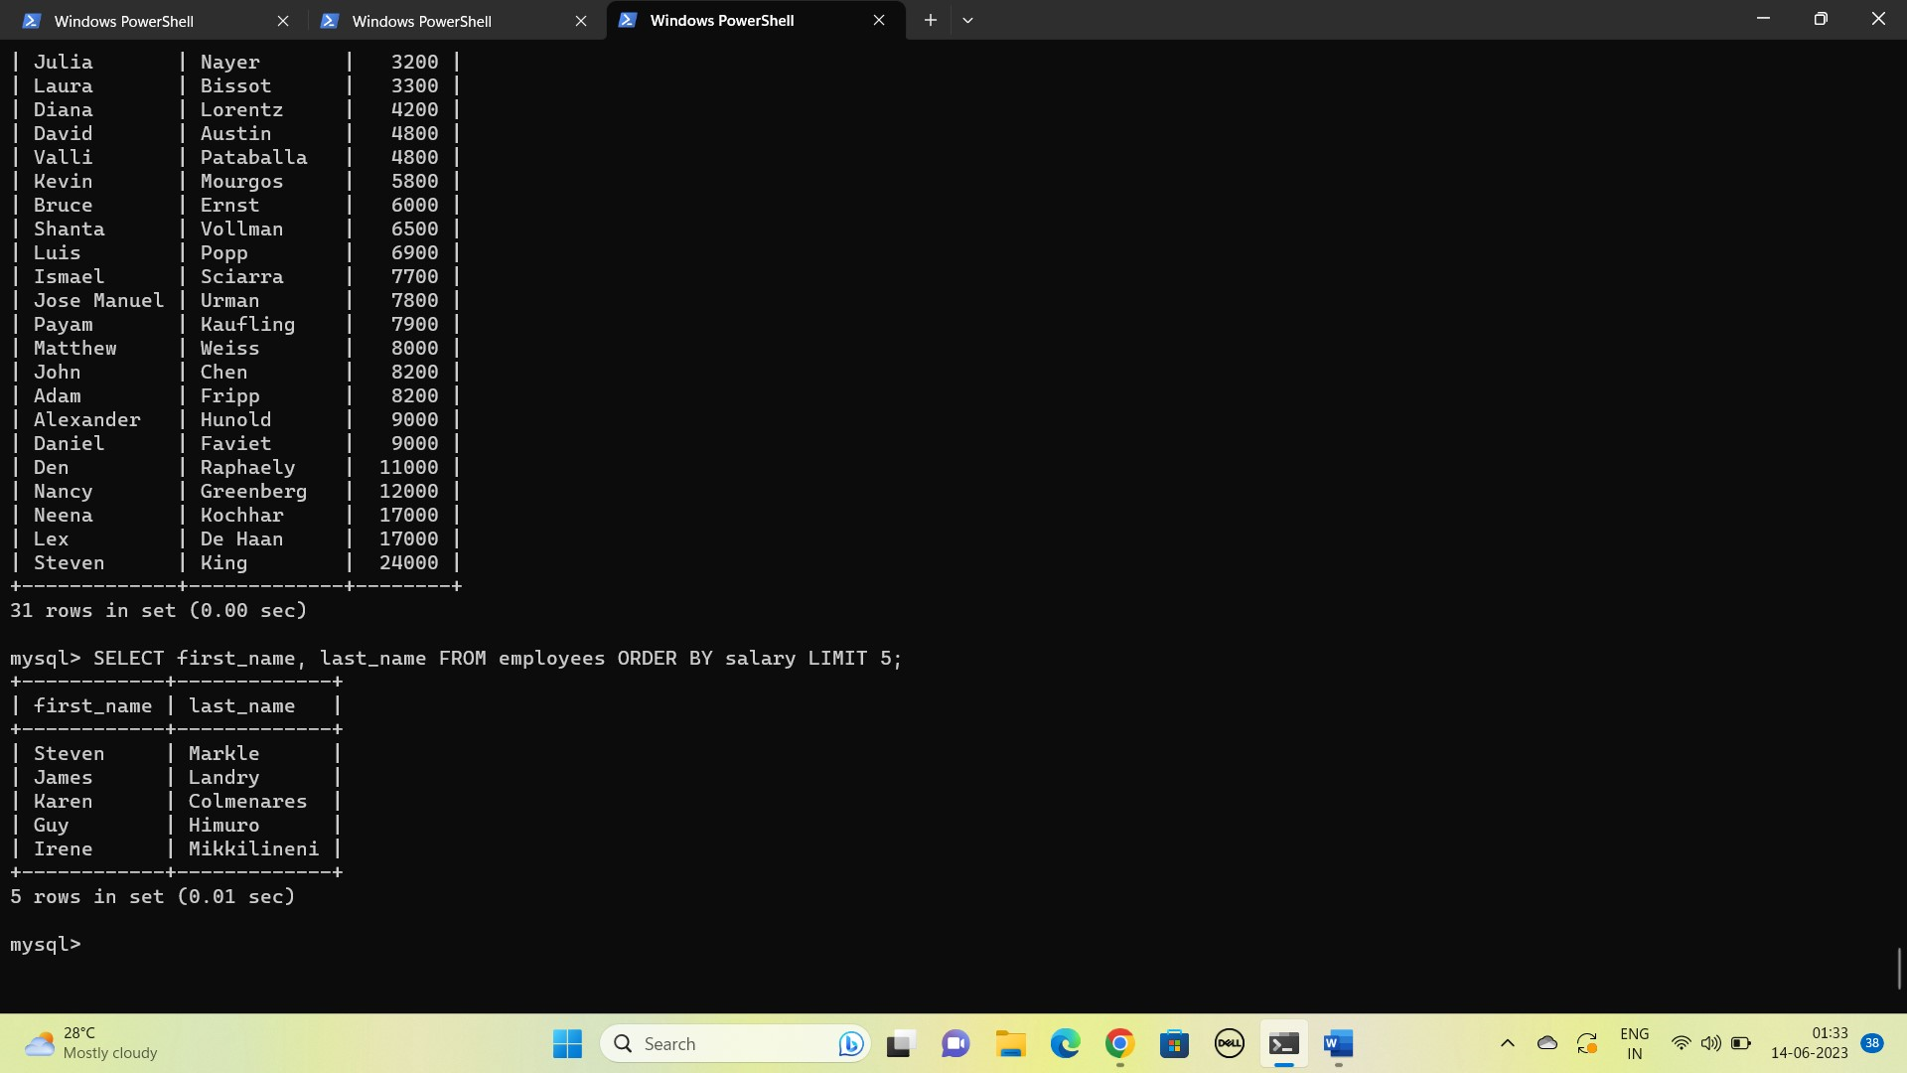

15. Find the employees hired in the 80s

SELECT first_name, last_name FROM employees WHERE hire_date LIKE '198_-%-%';

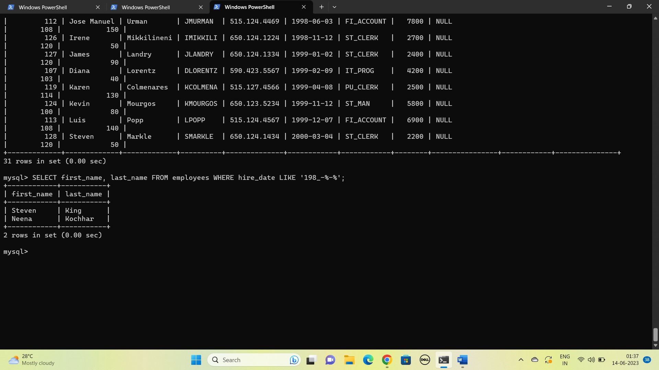

16. Find the employees who joined the company after 15th of the month

SELECT first_name, last_name FROM employees WHERE DAY(hire_date)>15;

